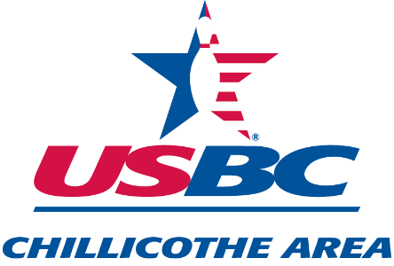

**SENIOR SINGLES HANDICAP TOURNAMENT**

**SHAWNEE LANES**

**1680 NORTH BRIDGE STREET**

**CHILLICOTHE, OHIO**

**SUNDAY, MARCH 16, 2025**

**SQUAD TIME 1:00 P.M.**

**THIS IS A NON-SANCTIONED TOURNAMENT**

**PRIZE MONEY RETURNED 100%--PRIZE RATIO 1 OF 5**

**ENTRY FEE: $20.00**

**PRIZE FUND: $11.00 LINEAGE: $9.00**

**MAKE CHECKS PAYABLE TO CHILLICOTHE AREA USBC**

**LEAVE ENTRIES AND PAYMENT AT FRONT COUNTER,**

**ATTENTION: TIM ANDERSON (I HAVE A BOX THERE)**

**CHECKS PAYABLE TO: CHILLICOTHE AREA USBC**

**ENTRIES MUST BE PAID IN FULL WHEN SUBMITTED**

**NAME_____________________________________________________**

**PHONE NUMBER_____________________**

**DATE OF BIRTH______________________**

**AGE AT DAY OF TOURNAMENT_________**

**AVERAGE: ____________**

**ENTRY DEADLINE IS MARCH 13, 2025**

**50/50 RAFFLE**

**RULES FOR THE 2025 CHILLICOTHE AREA USBC SENIORS**

**SINGLE HANDICAP TOURNAMENT**

**ENTRIES WILL CLOSE MARCH 13, 2025.**

**NO REFUNDS AFTER THE CLOSING DATE OF MARCH 13, 2025.**

**THERE WILL BE 4 SEPARATE DIVISIONS FOR BOTH WOMEN AND MEN**

**DIV. I--75 YRS OF AGE & ABOVE DIV. III-- 58 YRS - 64 YRS**

**DIV. II--65 YRS TO 74 YRS DIV. IV-- 50 YRS – 57 YRS**

**THIS WILL BE A CLASSIFIED HANDICAP SINGLES TOURNAMENT CONSISITING OF THREE GAMES. TOTAL PINS FOR THE 3 GAMES INCLUDING HANDICAP OF 100% BASED ON 200 SCRATCH FOR WOMEN AND 220 FOR MEN WILL DETERMINE THE WINNER IN EACH DIVISION.**

**ENTRANTS WILL USE THEIR FINAL LEAGUE AVERAGE AS OF THE END OF THE 2023-2024 WINTER OR SUMMER SEASON OF AT LEAST 12 GAMES OR MORE. IF NO 2023-2024 SEASON AVERAGE, BOWLER MAY USE HIGHEST CURRENT LEAGUE AVERAGE OF AT LEAST 21 GAMES AT TIME OF BOWLING. IF NO QUALIFYING AVERAGE, ENTRANT MUST BOWL SCRATCH.**

**3 BOWLERS PER LANE NO EXCEPTIONS.**

**ANY BOWLER ARRIVING LATE SHALL BEGIN PLAY AND THE SCORE SHALL COUNT BEGINNING IN THE FRAME THEN BEING BOWLED, TAKING ZEROS FOR MISSED FRAMES.**

**ANY DISPUTES REGARDING THIS TOURNAMENT IS THE DECISION OF THE CHILLICOTHE AREA USBC BOARD AND SHALL BE FINAL.**